# Vectors

Unit vector magnitude always equal to 1.

Always equal to 1 regardless of direction

Length =

= 5

Direction = (3/5,4/5)

= (0.6,0.8)

a =

= 10

Unit vector = (6/10,8/10)

= (0.6,0.8)

# Scaling

(7,5)

a.b = 4*1+1*-2

= 2

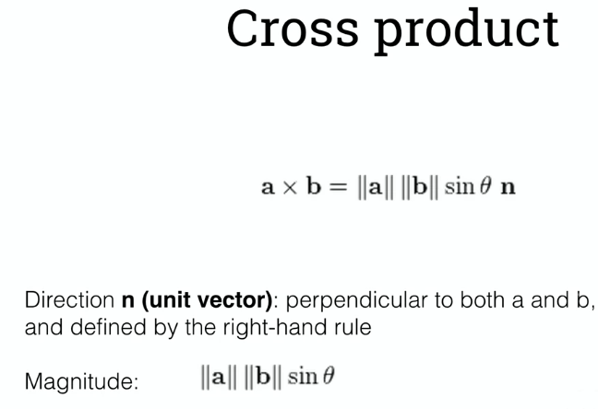

# Quiz



# **Objects and Meshes**

Summative quiz

||4,5,3|| =

= 7.07

||6,3,8|| =

= 10.44

(6/10.44, 3/10.44, 8/10.44) = (0.574, 0.287, 0.766) ≈ (0.57, 0.29, 0.77)

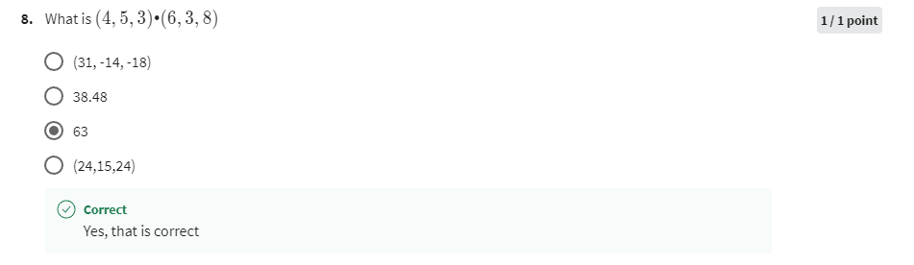

(4, 5, 3) · (6, 3, 8) = ax × bx +ay × by + az x bz

= 4*6 + 5*3 + 3*8

= 63

(4, 5, 3) × (6, 3, 8)

=

= 5*8 - 3*3

= 31

=

= 3*6 – 4*8

= -14

=

= 4*3 – 5*6

= -18

(4, 5, 3) × (6, 3, 8) = (

= (31, -14, -18)

Distance =

=

= 6.4